**Specification**

1. Introduction

This is a maze exploration system that integrates hardware and software. With simple controls, you can let the troller explore the maze and find treasures, and you can also log on to the website to find information about the robot. This system mainly consists of three parts, which are hardware (troller), treasure recognition program and website.

What you need to prepare: 3×18650 battery, 1×PPP3 battery, 1×computer that supports Wi-Fi, 1×smartphone with Android OS that supports Bluetooth, 1×cable that connects the smartphone with computer.

1. Let it run

The routing program has been imported into the board. The only thing that you need to do is to install the battery and switch on. The location of the battery and switch is shown in the figure below.

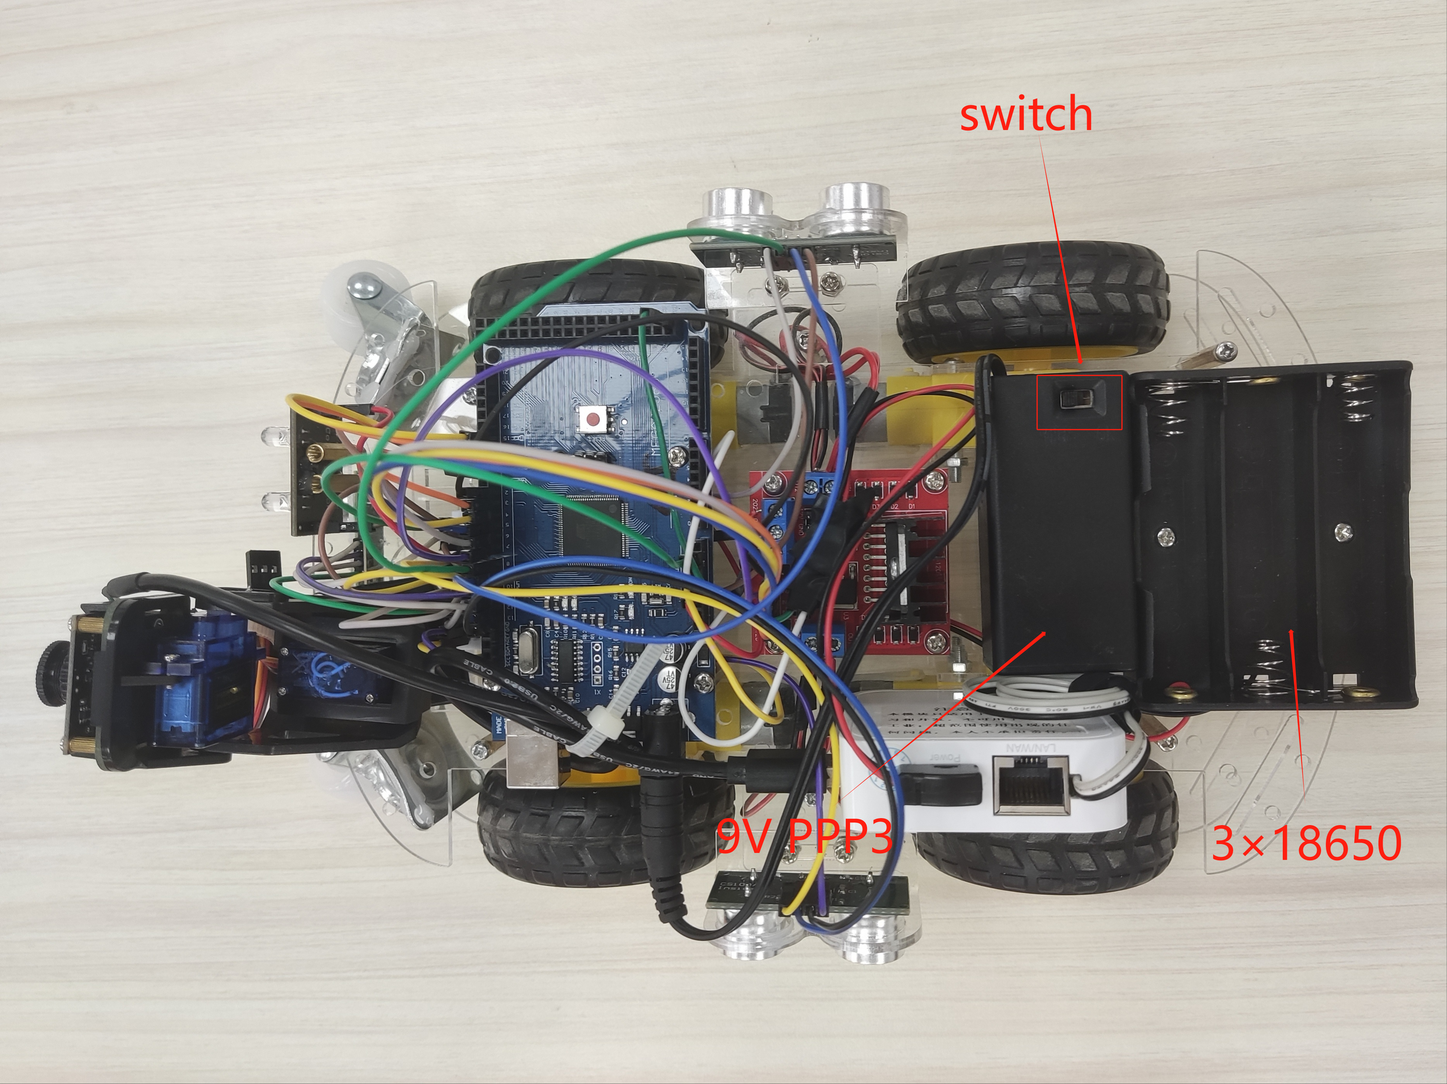

When it returns to the entrance of the maze, you need to switch off. Please make sure there is no battery when it is left unused.

1. Trolley communication

The trolley sends three ultrasonic sensors’ data through Bluetooth and sends real-time images via Wi-Fi module.

3.1 Connect to Wi-Fi

Before connecting, you must check the Wi-Fi module is powered on and the camera has been connected to Wi-Fi module with USB cable.

It may take some time to set up, you need to wait for half a minute. After your computer find the Wi-Fi, you can connect to it as normal.

Wi-Fi name: hjwifi2014_59

Password: 11111111

3.2 Connect to Bluetooth

Install “eDebugger” app in your Android phone. It’s been inside the file.

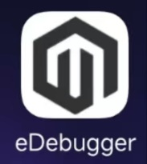

Connect your phone with computer. This action requires your Android phone to be in developer mode (search on Google if you do not know how to do, or check appendix A.1). If everything is right, a pop-up may be shown on your smartphone. Choose “File transfers”.

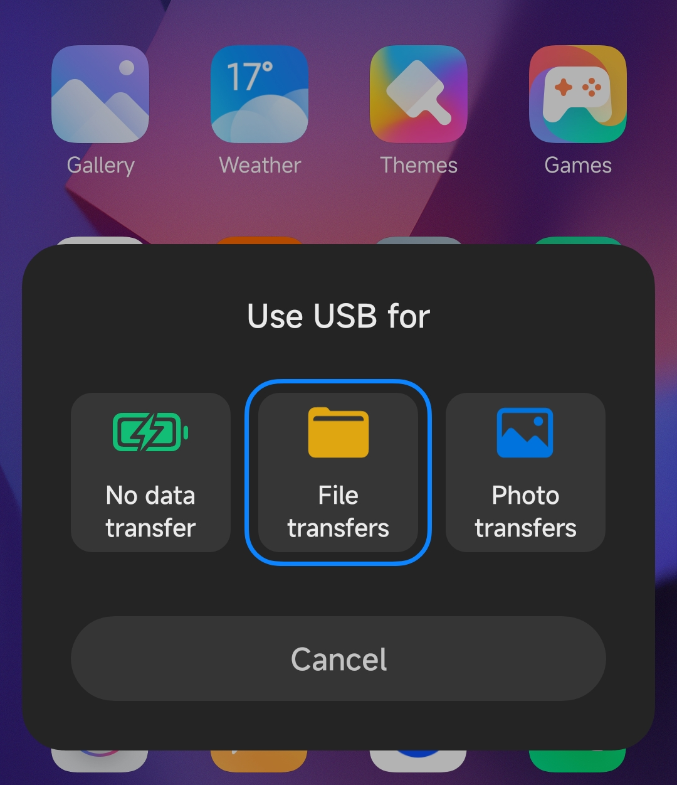

Launch “eDebugger”, find “Classic” in the bottom bar, and click “JDY-31-SPP”. 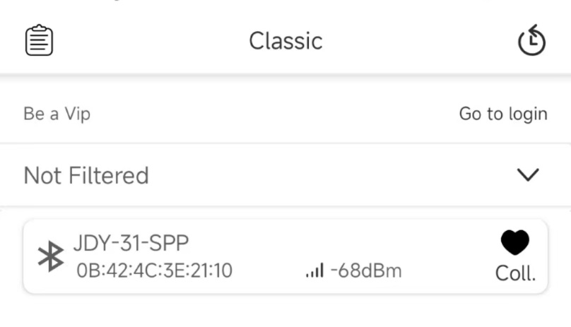

If it is your first link to this Bluetooth module, you should enter the PIN code, that is “1234”. After connection, you can see sensors’ data received. 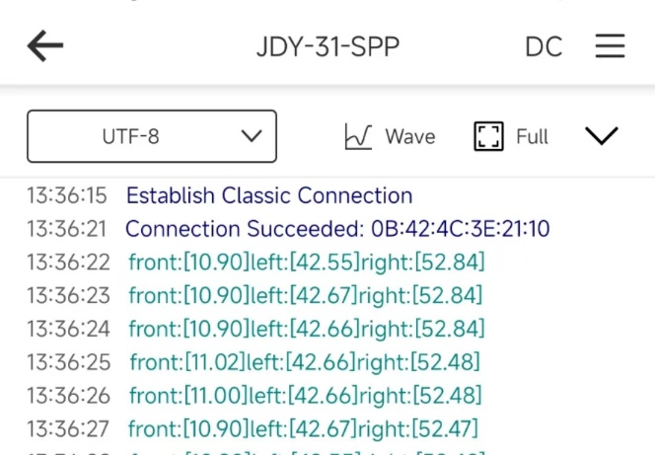

You must save the log at least once before launch the program in computer.

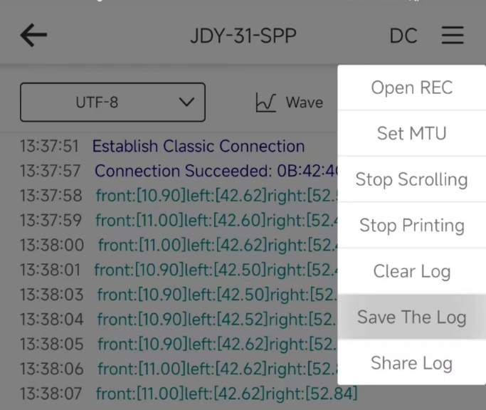

Upload the data to computer. Find “version 3.1” in the file, open it, and open a command line window in the current directory. Type in “java -jar CarDataDB-3.1.jar” in cmd (before doing this, you must configure environment variables) and press Enter. Every second you can see the data refreshed in real time. If you want to upgrade the data, please store it on your phone (you can also use tools that automatically do so). 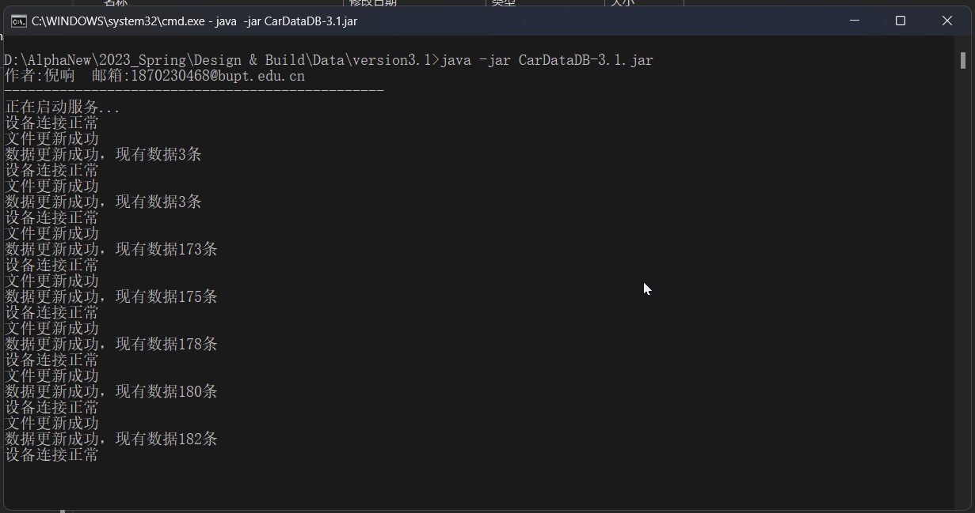

If you want to view the data on your computer, you need to visit the localhost, port 1919. Use IDEA for example. Check appendix A.2 for detailed guidance.

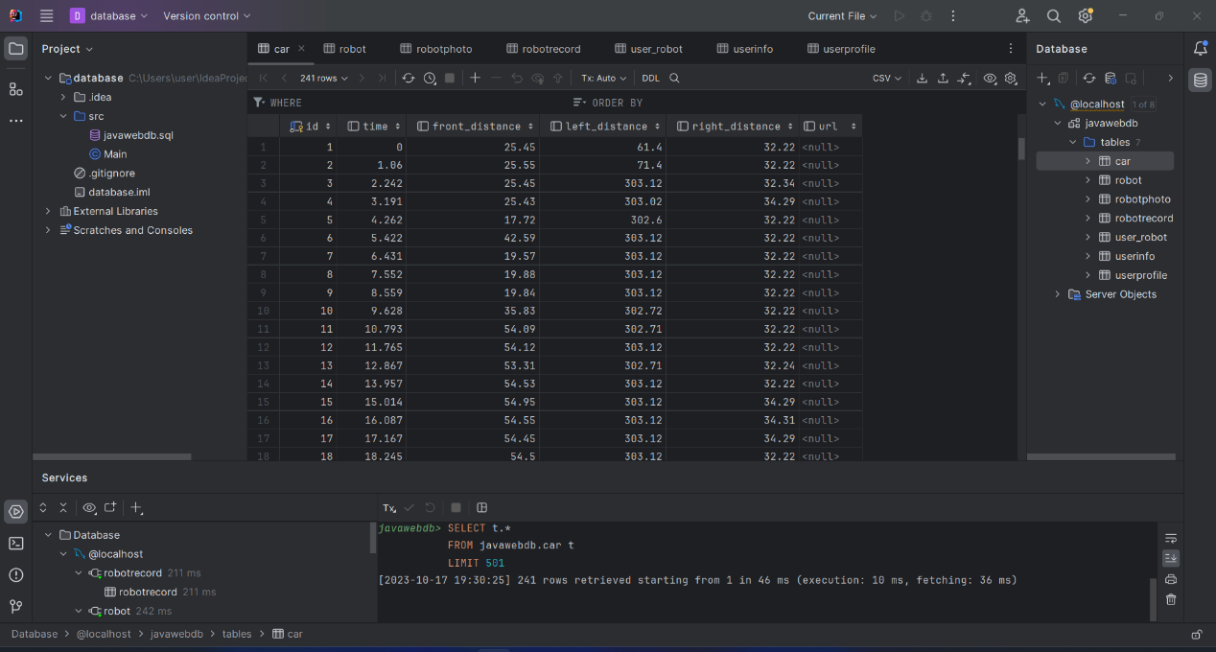

1. Treasure detection

4.1 Image Crawling

After successfully connecting your computer to the WiFi module of the smart car, you can write a web crawler using Python to access the website where the car's camera uploads images. You can crawl the website every 0.01 seconds and save the images in a local folder on your computer for further image recognition.

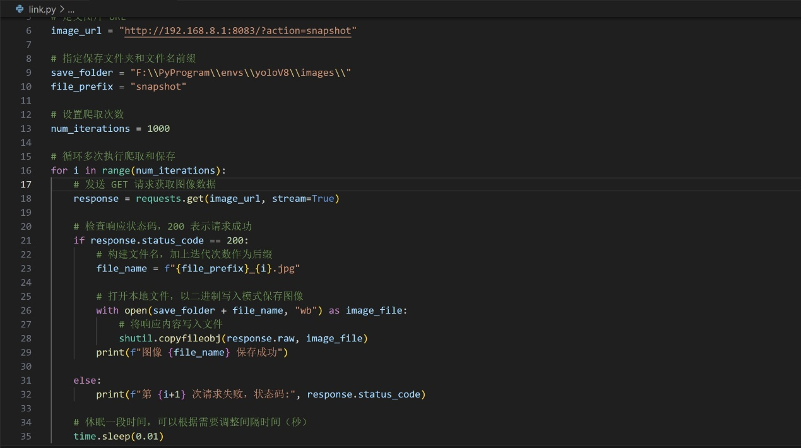

4.2 Image Prediction

Using the image recognition model trained in the first phase based on YOLOv8, you can perform recognition on all the images in a local folder and save the results in a "prediction" folder.

In the first phase, the model was trained for three types of items: books, Rubik's cubes, and keys. The training dataset consisted of approximately 1500 images for each item, and the model went through 100 iterations.

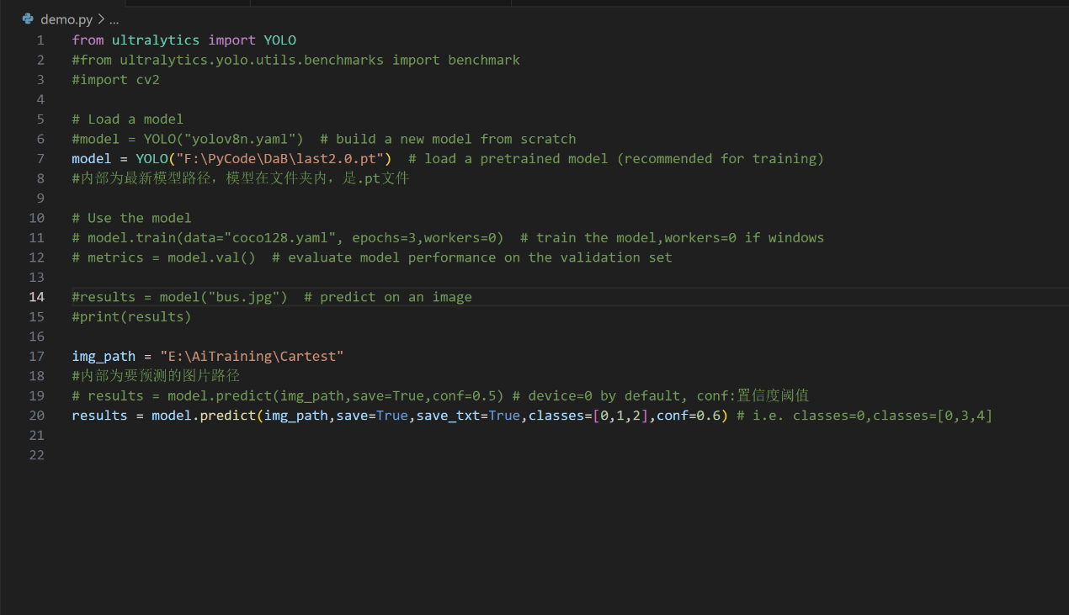

4.3 GUI

Select original images crawled from the website before prediction and compare them with the images saved in the "Prediction" folder after prediction. Implement functionality that allows you to navigate through these images by clicking "Previous" and "Next" buttons for before-and-after comparisons.

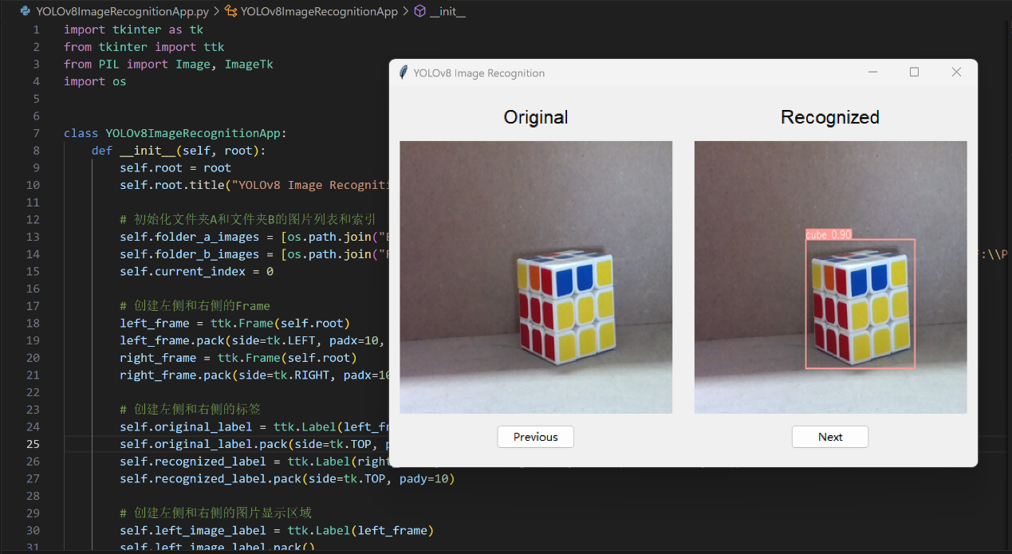

1. Website

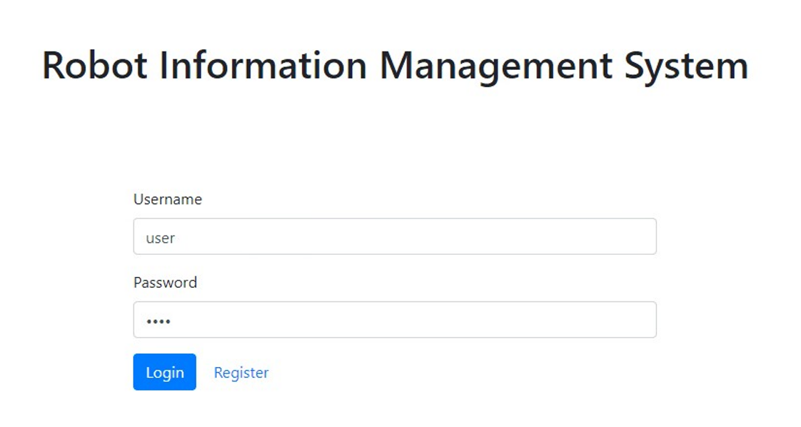

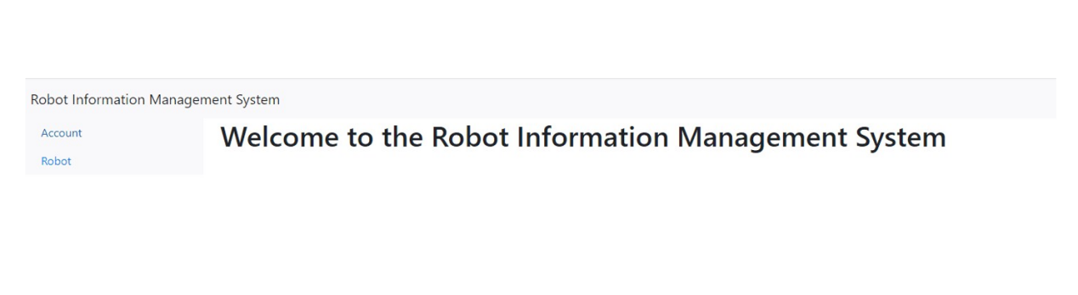

5-2 User information modify and save

After logging in successfully, we can modify the user information and save. The information will upload to the database .

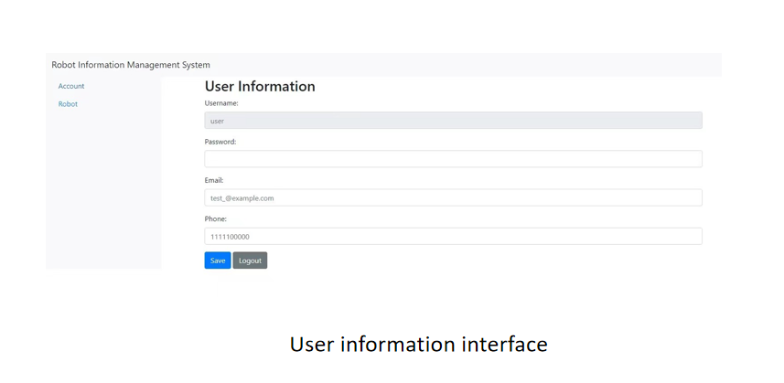

5-3 Robot information display

After clicking ‘robot’ the website will read the basic information about the robot related to the user from database.

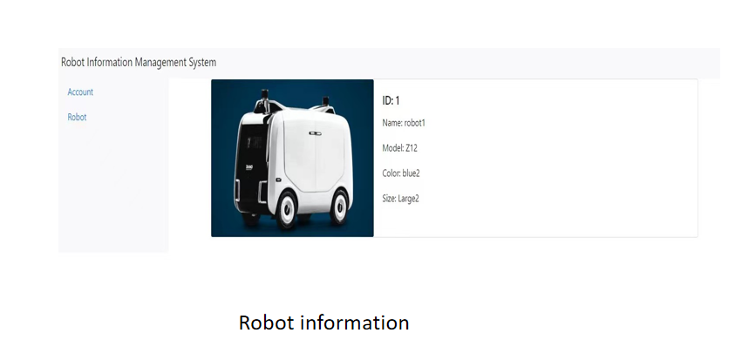5-4Robot exploration data display

Clicking the image of robot information displaying, the website will turn to the page of real-time robot exploration data display. Related messages are shown.

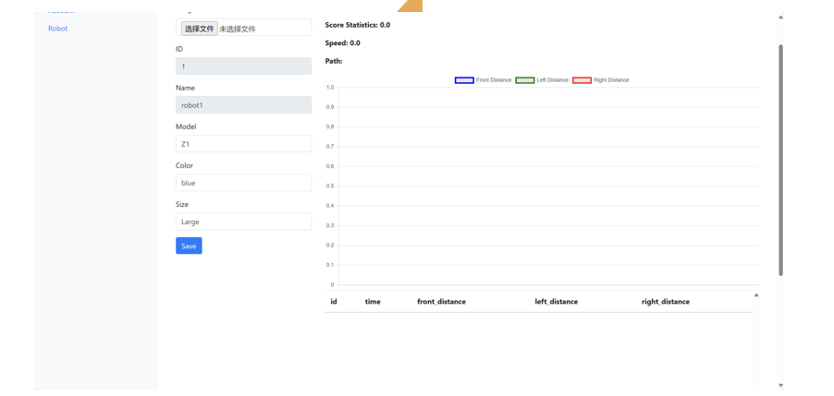

5-5Project development and operation environment

Operating system: Windows

Programming language: java

Integrated development Environment: Eclipse mySQL8.0

Running environment: jdk-19 tomcat8.5

**Appendix**

**A.1 Developer mode**

Take Xiaomi phone as example.

Settings→My device→detailed info and specs→MIUI version (5 clicks)

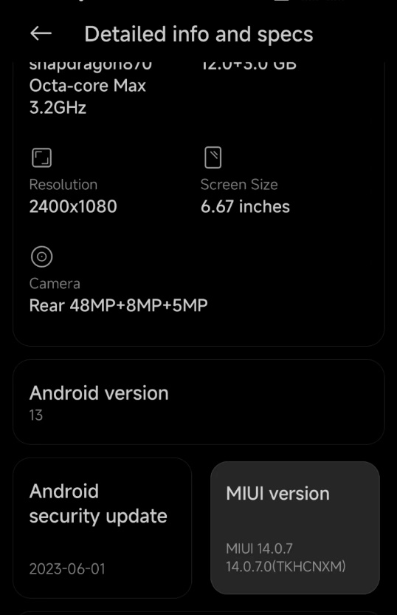

**A.2 Check the data in localhost**

This demonstration is based on IntelliJ IDEA 2023.2.3 and MySQL. Launch IDEA, click File→New→Project, modify the name if you prefer.

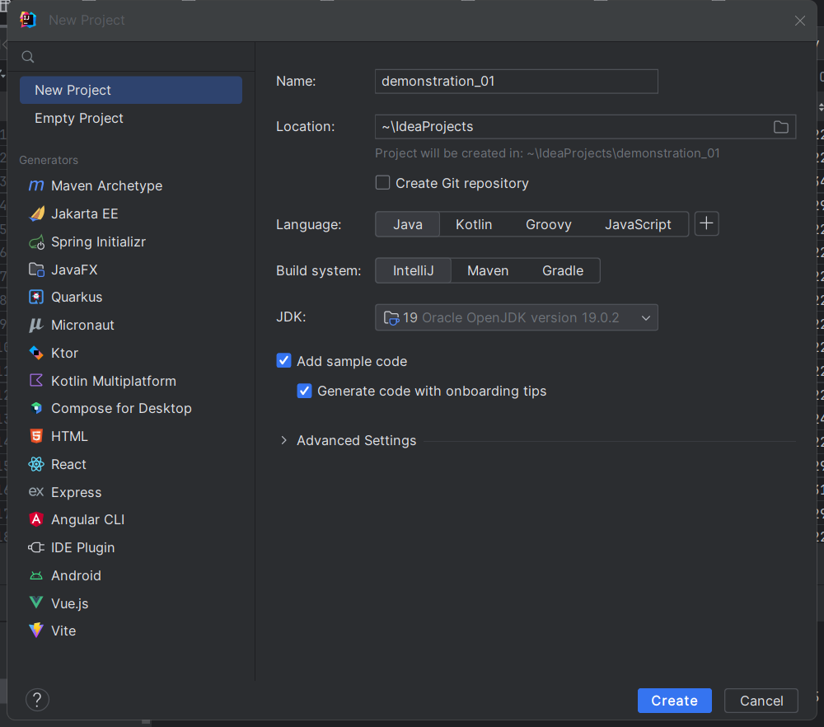

Click “Create”. Find “Database” at the right column, click as follows.

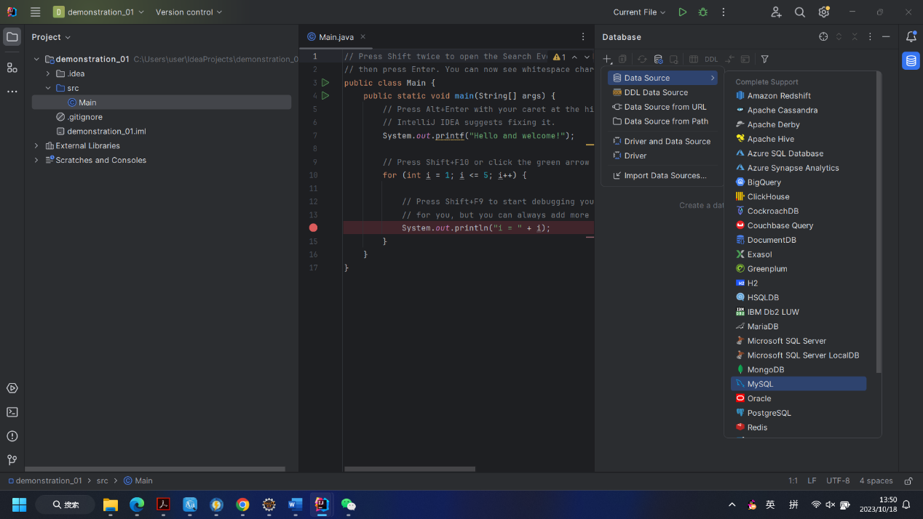

Then, make sure you are visiting localhost at port 1919. The user is “root” and the password is “2021212567”. You can also select “javawebdb” as database if you are interested in this trolley’s information.

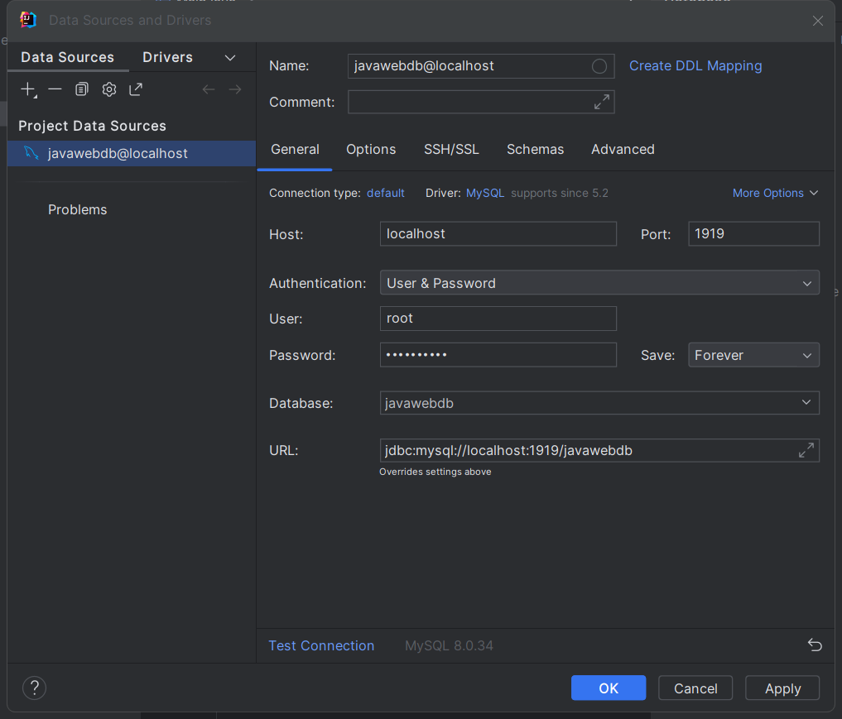

Now, you can view sensors’ data.   
